

**Data Visualization**

**Assignment**

**BY**

# INTRODUCTION

Cricket is one of the famous sports globally. And it has a greater number of fans following next to the soccer with around 2.5 billion widely spread across India, England, Pakistan, South Asia, Australia. International level Cricket is contending in 3 formats i.e. Test, ODI and T20I cricket. Nowadays T20 cricket is becoming famous because of the shorter format of the game and its entertainment factor. There are few Tournament conducted by countries to promote T20 format and IPL which is conducted by BCCI makes more revenue and has highest number of fan followers when compared to the other tournaments. According to survey conducted by ESPN and sporting Intelligence Magazine per annum typical IPL wage once pro-rated is US$4.33 million which is the second highest among all the sports leagues. Due to the involvement of money, team spirit, city loyalty and a massive fan following, the outcome of matches is very important for all stake holders. This, in turn, is dependent on the complex rules governing the game, luck of the team (Toss), the ability of players and their performances on a given day.

# BUSINESS QUESTION

1. Helping the coaching staff and franchisees in looking for better players
2. How players performances depend on team victory
3. Helping the Players in order to perform
4. Which team produces the best player

DISCOVERIES AND INSIGHTS

In our project we are building RSHINY application to evaluate the performance of players. This tool provides a visualization of performance of each player by their categories. For this we used the delivers.csv and matches.csv from Kaggle repository ( <https://www.kaggle.com/manasgarg/ipl> ).

As we progress, we build up multi-dimensional views for our analysis questions.

Figure: Bowlers stats

The above graph depicts about the bowler performance throughout the 2017 year here we built many drop-down buttons for selecting the year, stage of the match, innings, metrics view. In metrics view we can have built many options to check the bowler’s performance like based on over base, wickets, economy etc. By selecting the appropriate inputs, we can get our desired output. In the above graph we can see that the JJ Bumrah had bowled the maximum overs in 2017 with 20 wickets in his bag with an average of 21.6 followed by Narine, Mclenaghan, Rashid khan.

Figure: Bowler analysis

In the above graph we are comparing the bowling performance of two bowlers. For this we have built four drop-down buttons form which we can select two players and two parameters. In the above graph we have selected B Kumar and Steyn and here we are comparing their number of wickets and their economy from 2008 to 2017. Here we can see that in 2008 Steyn started his carrier and in 2011 B Kumar started his IPL carrier but franchises did not retained Steyn from 2015 its all because of his performance here we can see that his wicket taking capability decreased after 2014 from 18 to 11 and if we have look at his economy also increased to 7.4 which is not at all good for bowlers so no franchise showed interest to buy him.

Figure: Batsmen stats

The above graph depicts about the Batsmen performance throughout the 2017 year here we built many drop-down buttons for selecting the innings, metrics view, year, stage of the match. In metrics view we can have built many options to check the batsmen performance like based on run made, boundaries, sixes, fours. By selecting the appropriate inputs, we can get our desired output. Here we can see that Amla has more batting average, but he has played a smaller number of matches when compared to other players.

The above figure shows the overall performance of batsman with respect to run scored in a particular year. Here we can see that David warner outperformed when compared to other parleys in terms of run making to do this, he faced 462 balls and his highest run in that year is 62 and also, he smashed one century in that year. Gambhir, Dhawan, Smith, Raina are the batsmen who scored more runs followed by Warner.

## What is the average Team 1_ score?

As per the donut chart, Chennai Super Kings and Mumbai Indians had attained high scores when they are batting first.

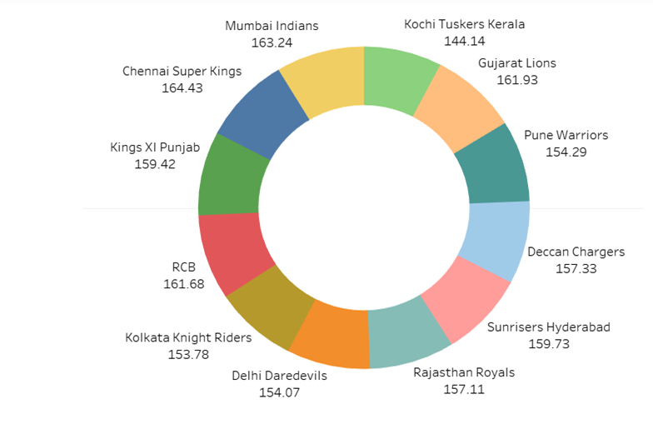

Chennai Super Kings and Mumbai Indias won the IPL Championships for the three times. Kolkata Knight Riders won the championship for two times. There are twelve teams in the dataset. Out of 12, only six teams won the championship. The championship has never been won by Royal Challengers, Delhi Daredevils, King XI Punjab, Pune Warriors, Gujarat Lions and Kochi Tusker.

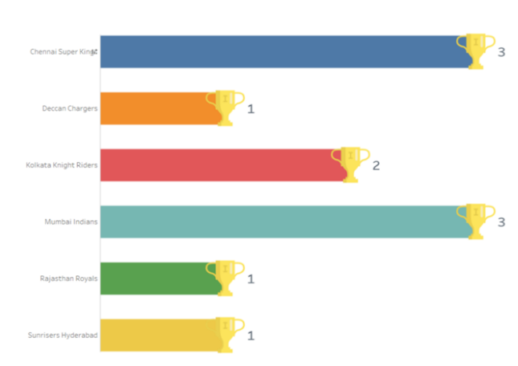

The below map shows that a number of matches played across India. The highest number of matches were played in Mumbai, Kolkata, Bangalore and Delhi. Also, season 2009 and 2014 happened in South Africa and UAE and the same was not shown in the below map.

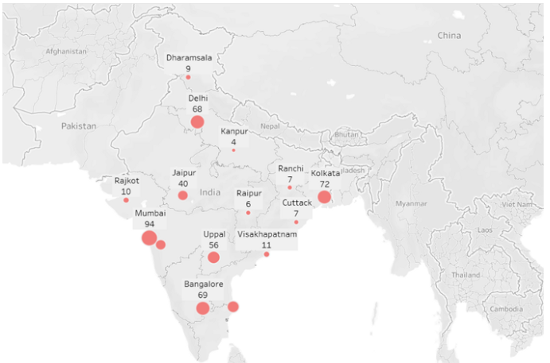

SUMMARY

From our overall analysis we can help each franchise to build their team looking at their performance and it also helps the players to have a look at there both positive and negative things which intern helps them to overcome from there problem and they can give their best at the ground.

Github URl: <https://github.com/krishna10519058/CA02datavisualization/upload>